SCSR2043 (Operating Systems)
Test 2 Revision

OBJECTIVE
- A good process scheduling policy will offer the following criteria EXCEPT:
 | A) Maximize throughput | C) Minimize response time
 | B) Maximize turnaround time | D) Maximize CPU efficiency

- The First Come First Serve (FCFS) scheduling algorithm first ________.
A) executes the job that came in last in the queue
B) executes the job that has maximum processor needs
C) executes the job that needs minimal processor
D) executes the job that came in first in the queue

- Which of the following algorithms tends to minimize the process average waiting time?
 | A) First Come First Serve | C) Shortest Job Next
 | B) Round Robin | D) Longest Job First.

- Which of the following statements is TRUE about Round Robin scheduling algorithm?
A) Best for Batch and Interactive environment
B) The easiest to implement
C) Requires selection of good time quantum
D) None of the above.

- Preemptive Shortest Job Next (SJN) is sometimes called
 | A) First Come First Serve (FCFS) | C) Round Robin (RR)
 | B) Shortest Remaining Time (SRT) | D) Shortest Job First (SJF)

- Consider the following table with a set of processes, the length of the CPU burst time given in milliseconds (ms): (Note: Shortest Job First (SJF))

Process | Burst time
P1 | 6
P2 | 8
P3 | 7
P4 | 3

Assuming all of the above processes arrive at t₀ , and SJF scheduling algorithm is used, calculate the waiting time for process P3.
 | A) 3 ms | C) 9 ms
 | B) 14 ms | D) 16 ms

- __________ was invented to allow processing time to be dynamically shared among a number of active applications.
 | A) Buffer | C) Multiprogramming
 | B) Batch processing. | D) Critical section

- Which of the following statements is not the advantage of process cooperation?
 | A) Data consistency. | C) Convenience
 | B) Modularity. | D) Information sharing.

- Which of the following statements best describe concurrency?
A) It is also known as independent processes.
B) Many concurrent processes are sharing the same data.
C) Execution of processes are interleaved in time to yield the appearance of simultaneous execution.
D) Breaking a task into several subtasks, each of which executes concurrently.

- Which of the following statements is FALSE regarding to Producer-Consumer problem?
A) Producer puts data in one slot while consumer retrieves data from another slot.
B) Consumer process needs to wait if buffer is empty.
C) Producer process needs to wait if buffer is full.
D) Producer process needs to wait if buffer is empty.

- Incorrect process synchronization can result in the following situation(s).
 | A) Starvation | C) Race condition
 | B) Deadlock | D) All of the above

- Which of the following statements is TRUE regarding race condition?
A) Race condition also means starvation.
B) In a multiprogramming environment, several processes may compete for a finite number of shared resources.
C) Race condition is a significant problem that can arise in a community of independent and non-cooperating processes.
D) Race condition can be avoided by allowing all four necessary deadlock conditions to hold.

- To meet the requirements of mutual exclusion on shared resources for competing concurrent processes, only one process at a time is allowed ______.
A) to execute the remainder section of the program
B) to execute in the critical section of the program
C) to be in operation in order to avoid race condition
D) to wait at the entry section of the program

- Which of the following statements describe Critical Section correctly?
A) The most important part of a program.
B) The part of a program that initialized global variables.
C) If a program executes its Critical Section, the program is said to be in race condition or critical condition.
D) The section(s) of program that manipulate shared resource(s) among cooperating processes.

- In a uniprocessor system, mutual exclusion can be achieved by all of the following tools EXCEPT :
 | A) interrupts. | C) by following Peterson’s algorithm
 | B) by using Semaphores. | D) Test-and-Set

16 | A solution to the problem of indefinite blockage of low-priority processes is _________.
 | A) starvation | C) wait queue
 | B) aging | D) ready queue

17 | Which of the following statements are TRUE about priority scheduling algorithm?
 | A) it schedules in a very complex manner.
 | B) its scheduling takes up a lot of time.
 | C) it can lead to some low priority process waiting indefinitely for the CPU.
 | D) None of the above.
18 |  | Which of the following algorithms tends to minimize the process turnaround time ?
 |  | A) First Come First Serve. | C) Earliest Deadline First
 |  | B) Shortest Job Next. | D) Longest Job First.

19. Choose the transition states that are under preemptive process scheduling.
- RUNNING to WAITING
- WAITING to READY
- WAITING to RUNNING
- RUNNING to READY
A) i and iii | C) ii and iv
B) ii and iii | D) i, iii and iv

STRUCTURE
- Table below shows the trace addresses for 3 processes A, B, C and the dispatcher in memory. All processes are executed in sequence on a single processor. The execution begins with process C, followed by A and B. Process A request an I/O resource at instruction cycle 12 and waits up to 24 instruction cycles. Process C requests an I/O resource at instruction cycle 30 and waits up to 12 instruction cycles.

The processes and location.
Process | Addresses
A | 1600 - 1609
B | 2800 -2809
C | 10000 - 10009
Dispatcher | 200 – 204

Running
Blocked
Ready

Draw the process state figure for all processes within 65 instruction cycle with THREE (3) different indicators for running, ready and blocked state as show above. Assume the CPU time is 5 instruction cycles.

- Consider the following set of processes, with the length of the CPU-burst time given in milliseconds:
Process | Burst Time
A | 20
B | 4
C | 36
K | 8
S | 12
Consider the FCFS, SJF/SJN (Non-preemptive), and RR (time quantum = 12) scheduling algorithms for this set of processes. Which algorithm would give the minimum/best average waiting time (AWT) and minimum average turnaround time(ATT)? Show your work/computation and draw Gantt chart.

- Consider the following set of processes with arrival times as shown below:
Process |  | Arrival Time | Burst Time
A |  | 0 | 16
E |  | 3 | 10
S |  | 4 | 8
R |  | 8 | 4
K |  | 15 | 12
Z |  | 16 | 6
Use the SRT/SRTF algorithm to compute the average waiting time (AWT) and the average turnaround time (ATT) for this set of processes. Draw Gantt chart.
- Consider the following set of processes with arrival times as shown below:
Process | Arrival Time | Burst Time | Priority
M | 0 | 16 | 4
E | 3 | 8 | 3
S | 3 | 8 | 2
R | 8 | 4 | 1
A | 15 | 12 | 5
Z | 16 | 6 | 2
Note: Smaller priority number means higher priority.
Use the combine Priority and RR scheduling (time quantum=6) algorithm to compute the average waiting time (AWT) and the average turnaround time (ATT) for this set of processes. Draw Gantt chart.
- 5 process A, B, C, D and E arrived at t0 with different CPU burst and priority level as shown in table below. Assume multilevel feedback queue is applied with 2 queue levels (Q0 and Q1) and priority 1 is the highest. Q0 uses RR with time quantum = 5 and Q1 uses FCFS. Compute the average waiting time (AWT) and the average turnaround time (ATT). Draw Gantt chart.
Process | CPU Burst | Priority
A | 10 | 3
B | 3 | 1
C | 8 | 4
D | 2 | 5
E | 9 | 2

6.
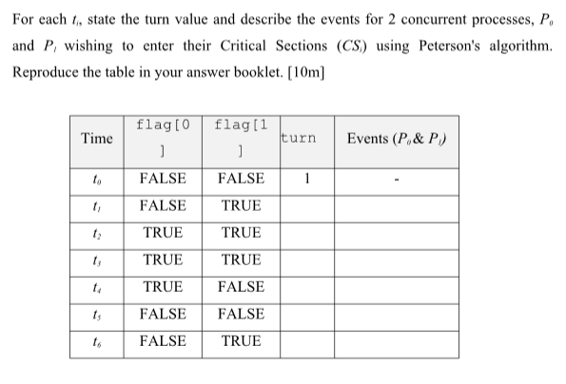
7. Peterson’s Algorithm: Given a code for Process 0 and Process 1 in Table 4. Fill in flags and turn variables if Process 1 initiates the request to enter the critical section.

Table 4

Process 0 | Process 1
do {  flag[0] = TRUE;  turn = 1;  while (flag[1] && turn == 1)  ; /* do nothing */  critical section  flag[0] = FALSE;  remainder section  } while (TRUE); | do {  flag[1] = TRUE;  turn = 0;  while (flag[0] && turn == 0)  ; /* do nothing */  critical section  flag[1] = FALSE;  remainder section  } while (TRUE);

Table 5

time | flag[0] | flag[1] | Turn | Events
t₀ | FALSE | TRUE | 0 | P₁ request to enter CS
t₁ | FALSE | TRUE | 0 | P₁ enters CS
t₂ | TRUE | TRUE | 1 | P₀requests to enter CS
t₃ | TRUE | FALSE | 1 | P₁ executes RS
t₄ | TRUE | FALSE | 1 | P₀enters CS
t₅ | TRUE | FALSE | 1 | P₁ executes RS
t₆ | FALSE | FALSE | 1 | P₀ executes RS
t₇ | FALSE | FALSE | 1 | P₁executes RS
t₈ | TRUE | FALSE | 1 | P₀ requests to enter CS

Justify your answer by showing:
- Mutual exclusion is preserved
- The Progress requirement is satisfied
- The bounded-waiting requirement is met

8. Consider a Producer-Consumer implementation. What would be the possible values of in, out, counter if race condition occurred at time T7 as shown in Table 1. Initially all shared variables are set to 0 values.
 | Table 1
 | Time | Producer | Consumer
 | T1 | Produce(A) | -
 | T2 | Produce(B) | -
 | T3 | Produce(C) | -
 | T4 | - | Consume(A)
 | T5 | - | Consume(B)
 | T6 | Produce(D) | -
 | T7 | Produce(E) | Consume(C)

9.

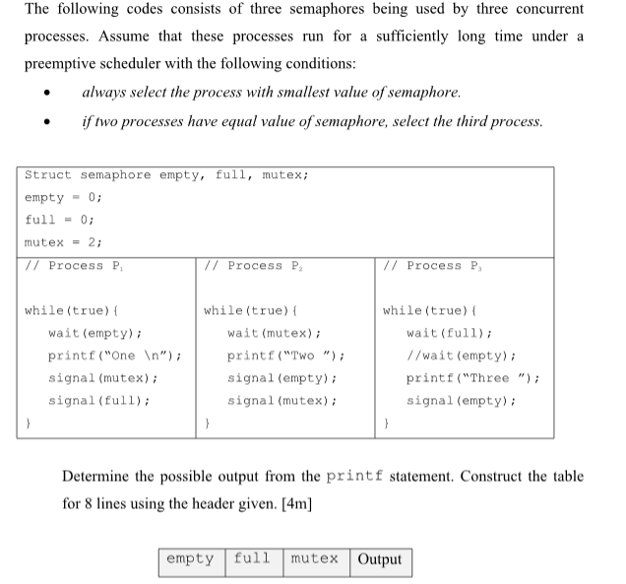

10. Based on the following sequence of statements for executing the three processes using semaphore operations, state the output for Table 8 to 11. Assume that all flags are initialized to 0. Possible output can be more than 1.

Table 8

P₀ | P₁ | P₂
wait(B_flag)  printf(“B “);  signal(C_flag) | printf(“A “)  signal(B_flag) | wait(C_flag)  printf(“C “)

Output :

Table 9

P₀ | P₁ | P₂
printf(“B “); | printf(“A “) | wait(C_flag)
signal(C_flag) | signal(B_flag) | printf(“C “)

Output :

Table 10

P₀ | P₁ | P₂
wait(B_flag) | wait(A_flag) | printf(“C “)
printf(“B “); | printf(“A “) | signal(B_flag)
signal(A_flag)

Output :

Table 11

P₀ | P₁ | P₂
wait(B_flag)  printf(“B “);  wait(C_flag) | printf(“A “)  signal(B_flag) | printf(“C “)  signal(C_flag)

Output :

11.

Figure 3 below shows the implementation of Producer-Consumer using Semaphores. Supposed the initial values of the buffer size, N=10, mutex=1, empty=9 and full=1.
Producer | Consumer
do {  produce an item  …  wait(empty);  wait(mutex);  …  add item to buffer  …  signal(mutex);  signal(full);  } while (TRUE); | do {  …  wait(full);  wait(mutex);  …  remove an item from buffer  …  signal(mutex);  signal(empty);  } while (TRUE);
Figure 3

i. Fill in or complete the value of the appropriate mutex variables in Table 5 if the following sequence of order is executed: consumer, producer.
Table 5
Process | Wait(full) | Wait(mutex) | Signal (mutex) | Signal (empty)
Current Value | 1 | 1 |  | 9
Consumer
Process | Wait(empty) | Wait(mutex) | Signal (mutex) | Signal (full)
Producer

ii. If the latest value of empty is 0, what can the Consumer do?
iii. How about the Producer when the value of empty is 0? Explain.
iv. Why the initial value of mutex variable should be set to 1?

